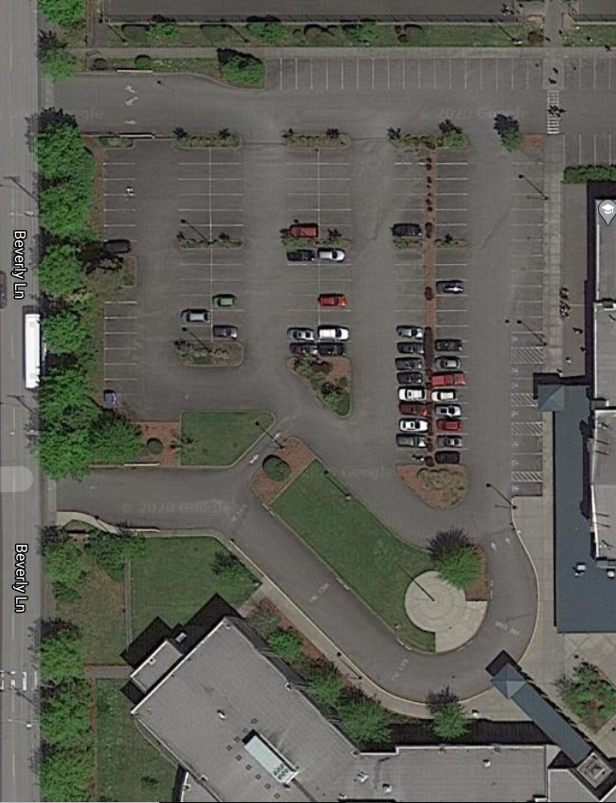

*Flag Pole*

**Drop Off**

*Text books/ library books/ teachers’ items/ band instruments/ Technology (optional)*

**Pick Up**

*Personal items/ medications/ student projects*

**Yearbooks!**

(*8th grader Celebration of Learning gift* bag)

**Check In**

*(Be prepared to share student name and id number)*

*GYM*

*Front Entrance*

*Main Building*

**Tuesday, June 16th (4:00-7:00pm)**

***8th Grade Celebration of Learning***

***8th Grade Drop Off/ Pick Up***

**Wednesday, June 17th (12:30-2:00pm or 3:30-5:00pm)**

***7th Grade Drop Off/ Pick Up***

**Thursday, June 18th (12:30-2:00pm or 3:30-5:00pm)**

***6th Grade Drop Off/ Pick Up***

**Friday, June 19th (8:00am-11:30am)**

***ALL Grades Drop Off/ Pick Up***

***Last Opportunity***

*Evergreen MS: End of Year*

*Drop Off/ Pick Up: June 16-19*

**Evergreen Middle School: End of Year Student Drop Off/ Student Pick Up**

|  |  |
| --- | --- |
| **Designated Grade Level** | **Date and Time** |
| **8th Grade Celebration of Learning**  **8th Grade Drop Off/ Pick Up** | **Tuesday, June 16th/ 4:00-7:00pm** |
| **7th Grade Drop Off/ Pick Up** | **Wednesday, June 17th/ 12:30-2:00pm or 3:30-5:00pm** |
| **6th Grade Drop Off/ Pick Up** | **Thursday, June 18th/ 12:30-2:00pm or 3:30-5:00pm** |
| **All Grades Drop Off/ Pick Up**  **Last Opportunity** | **Friday, June 19th/ 8:00am-11:30am** |

**Check In-** When entering the school from Beverely Lane on the westside of campus, you will be asked to give a student name and/or student id number. A students id number is also known as the student’s lunch or library number.

**Drop Off-** Students should drop off any school materials that were checked out prior to the closure. Please have these items ready to hand out through a window of the car.

* **Text Books-** Any text books that the student had issued to them during the school year must be returned at this time. We complete summer inventories to ensure future students have access to these materials.
* **Library Books-** Any library book that the student checked out from either their teacher or the school’s main library must be returned at this time. All library books are cataloged, repaired and reselved during the summer to ensure there are books for next year.
* **Band Instruments-** All band instruments checked out from the school must be returned at this time for cleaning and repair. Please make sure the instrument is in its case. If the instrument is too large to hand through a window, please place it in the truck or backseat of the car for our employees to grab. If you have questions, please contact Joe Gudorf at [jgudorf@everettsd.org](mailto:jgudorf@everettsd.org).
* **Chromebooks/ Hotspots-** If you student would like to keep their checked out device during the summer to continue their online learning through I-Ready, please remember that the device is for school related purposes only. That the technology use agreement signed at the beginning of the school year still applies. If you are moving out of district or not interested in using it this summer, you can drop it off at this check point. Hot spots may also be returned if you have one. If you have any questions, please contact Mr. Ellsworth at [jellsworth@everettsd.org](mailto:jellsworth@everettsd.org).

**Pick Up-** We had an essential item pick up at the end of May, and this is the last opportunity to pick these items up before they are disposed or donated.

* **Personal Items-** Personal items such as gym clothes, shoes, hygene products, and other items have previously been bagged for pick up. For questions, please contact Amy Duffy at [aduffy2@everettsd.org](mailto:aduffy2@everettsd.org).
* **Medications-** The school nurse has been in the process of returning medications to students who had them stored in our nursing office. If you have questions, please contact Nurse Gail Pyper at [gpyper@everettsd.org](mailto:gpyper@everettsd.org).
* **Student projects-** School projects will also be available for pick up at this time. If you have a project, such as a science or shop, that was left in the building at the time of the closure, please contact your teacher to have it moved to our pick up area with your name and student Id number attached. Here is a link to our school’s staff directory: <https://www.everettsd.org/domain/369>.

**Yearbooks! (*8th grader Celebration of learning gift bag*)-** Students who have purchased a yearbook can pick those up at this time.

* Yearbooks- Please make sure to have your student’s name and student id number ready, so their name can be checked off our list. If you received a reciept, please bring a copy as well.
* 8th Grader Celebration of Learning gift bag- We have put together a gift for our amazing 8th graders transitioning to high school next year. On 8th grade pick up, staff members will be physically lining the path to express our appreciation and love for these students.

